Golden Motor Motor Test Report

Motor model(Type)： 3kw

Name of the organization(Company)： GOLDEN MOTOR Test manTest： 1

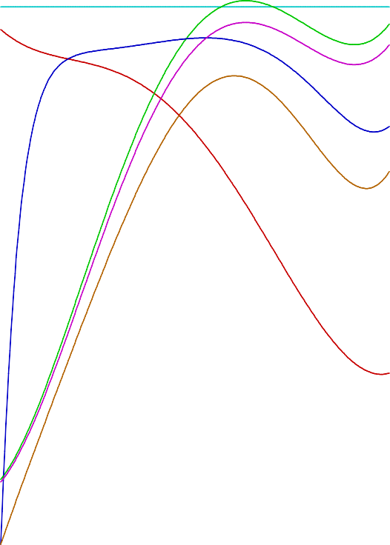Test date(Test Date):2014-12-31

|  |  |  |  |  |  |  |  |  |  |
| --- | --- | --- | --- | --- | --- | --- | --- | --- | --- |
| V S |  |  | If | I  Pin  F |  |  |  |  |  |
|  |  |  |  | Pout |  |  |  |  |  |
|  |  |  |  |  |  |  |  |  |  |
|  |  |  |  |  |  |  |  |  |  |
|  |  |  |  |  |  |  |  |  |  |
|  |  |  |  |  |  |  |  |  |  |
|  |  |  |  |  |  |  |  |  |  |
|  |  |  |  |  |  |  |  |  |  |
|  |  |  |  |  |  |  |  |  |  |
|  |  |  |  |  |  |  |  |  |  |

Rated voltage(Voltage)： 48 (V) Rated current(Current Rated)： 85(A)

Rated Power(Power Rated)： 3000 (W)

Rated speed(Speed Rated)： 4000 (r/m)

|  |  |  |  |  |  |  |  |  |  |  |  |  |  |
| --- | --- | --- | --- | --- | --- | --- | --- | --- | --- | --- | --- | --- | --- |
| U (V) | Pin (W) I(A) |  |  |  | Motor Load Characteristic curve |  |  |  | S(r/m) | After (W) | EFF(%) | Starting point(Start):0.7(Nm) |  |
| 50 | 5000 100.0 |  |  |  |  |  |  |  | 5000 | 5000 | 100 | Speed = 4489 (R/m)  Current = 14.87 (A) |  |
| 45 | 4500 90.0 |  |  |  |  |  |  |  | 4500 | 4500 | 90 | Maximum torque point(Max_Torque): |  |
| 40 | 4000 80.0 |  |  |  |  |  |  |  | 4000 | 4000 | 80 | Torque = 20.80 (Nm)  Speed = 1529 (R/m) |  |
| 35 | 3500 70.0 |  |  |  |  |  |  |  | 3500 | 3500 | 70 | Current = 92.93 (A)  Output power = 3329.3 In |  |
| 30 | 3000 60.0 |  |  |  |  |  |  |  | 3000 | 3000 | 60 | Efficiency = 74.64 (%) |  |
| 25 | 2500 50.0 |  |  |  |  |  |  |  | 2500 | 2500 | 50 | Maximum lossPower Point(Max_Pout):4184.6 Torque = 12.52 (Nm) | In |
| 20 | 2000 40.0 |  |  |  |  |  |  |  | 2000 | 2000 | 40 | Speed = 3191 (R/m)  Current = 96.89 (A) |  |
| 15 | 1500 30.0 |  |  |  |  |  |  |  | 1500 | 1500 | 30 | Efficiency = 89.97 (%) |  |
| 10 | 1000 20.0 |  |  |  |  |  |  |  | 1000 | 1000 | 20 | Highest efficiency point(Max_Pout):90.47 (%) |  |
| 5 | 500 10.0 |  |  |  |  |  |  |  | 500 | 500 | 10 | Torque = 11.06 (Nm)  Speed = 3539 (R/m) |  |
| 0 | 0 0.0 | 0.0 | 3.0 | 6.0 | 9.0 12.0 15.0 18.0 21.0 | 24.0 | 27.0 | 30.0 | 0  T(Nm) | 0 | 0 | Current = 94.38 (A) Output power = 4098.4 In |  |